Online store

Show your understanding of Angular.

**Part 1**

1. Complete the project from the [**tutorial**](https://angular.dev/tutorials)

**Part 2**

1. Create a new Angular project
   1. Implement the component **“Products”**, which shows the list of products. Each product must have the following properties:
      1. image
      2. name
      3. description
      4. rating
   2. Each product should be linked to a real item from [**kaspi.kz**](https://kaspi.kz/shop/)
   3. Must be at least 10 products
   4. Buttons “Share” for each product, by clicking, the user should be redirected to Whatsapp or Telegram with the link to the product
   5. Optional: Add product image gallery, minimum 3 images.

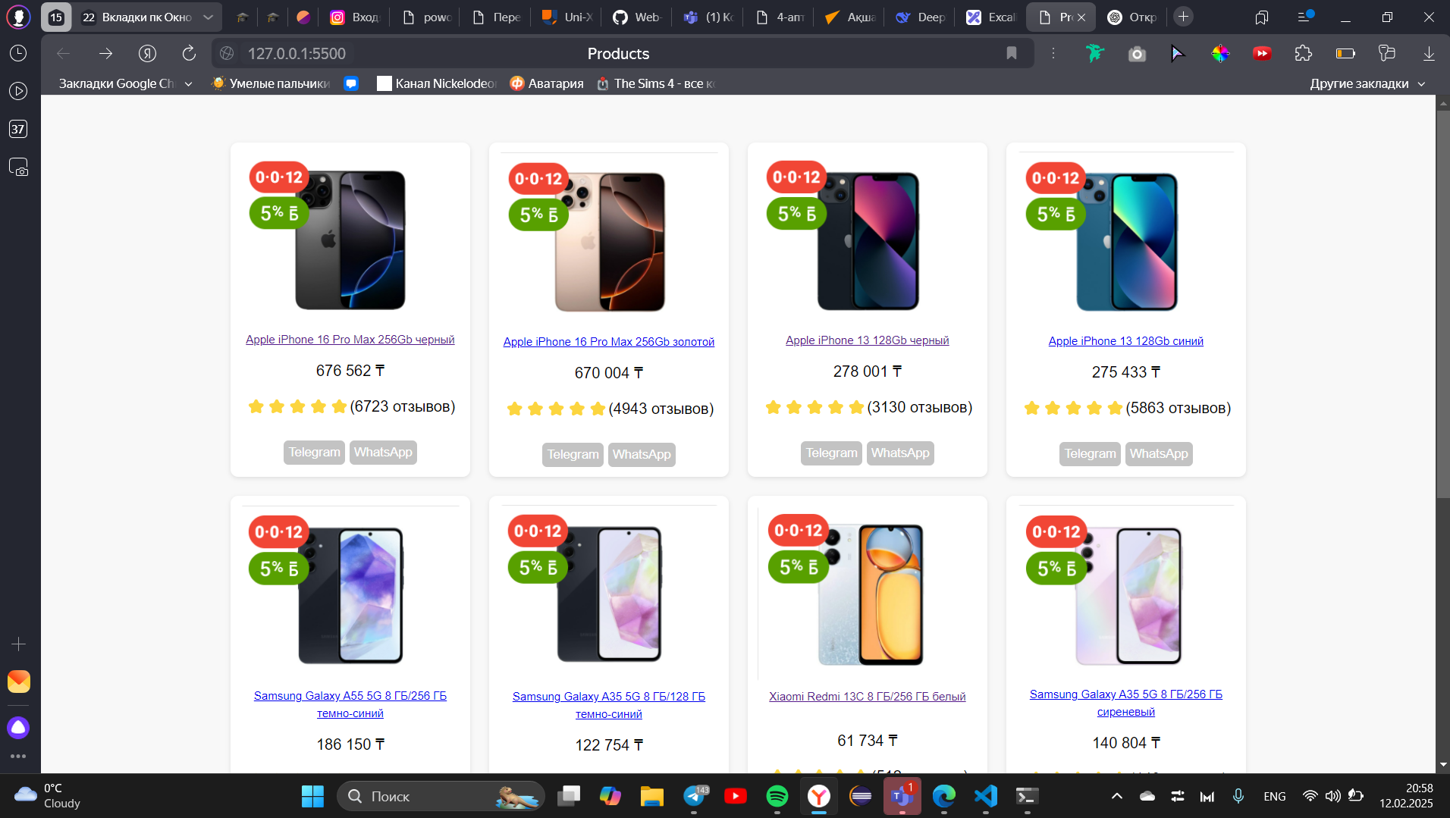

Useful links

1. https://angular.dev/overview
2. <https://nodejs.org/en/>
3. <https://www.npmjs.com/>
4. <https://www.jetbrains.com/ru-ru/webstorm/>

GOOD LUCK :)